Excel formatting guide
Cell A1 should be ‘Date:’ and B1 should be the date formatted as dd/mm/yyyy
Cell A2 should be ‘Room:’ and then the program will distinguish items in the same row as rooms
Times start from A3 and go downwards. They should have a colon in the middle (e.g. 08:30) so Excel recognises them as times
Key (This can all be customised – these are just some example categories with arbitrary colouring):
Names of speakers should be enclosed in <> e.g. <Sample Speaker>
[s] = Symposium event. These are highlighted green
[p] = Short papers session. These are highlighted blue
[v] = Exhibition. These are highlighted red
[e] = Education session. These are highlighted orange
[r] = Royal college lecture. These are highlighted purple
[n] = No event taking place – these should only need to be used rarely but will indicate that the event above has finished so will colour the cell white, rather than defaulting to the color of the cell above. (example below)

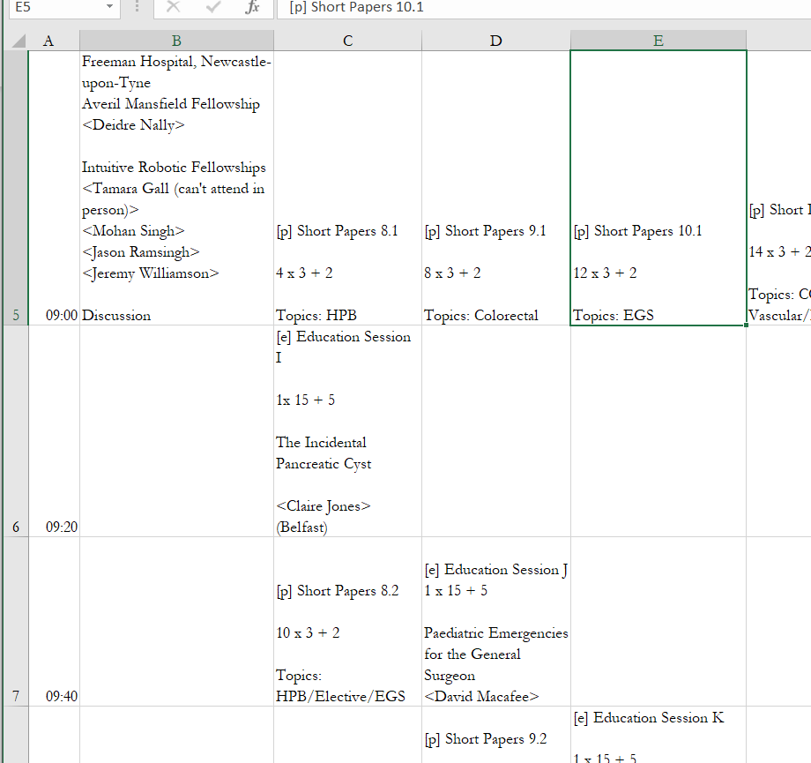

By default, the event in E5 would be displayed as :

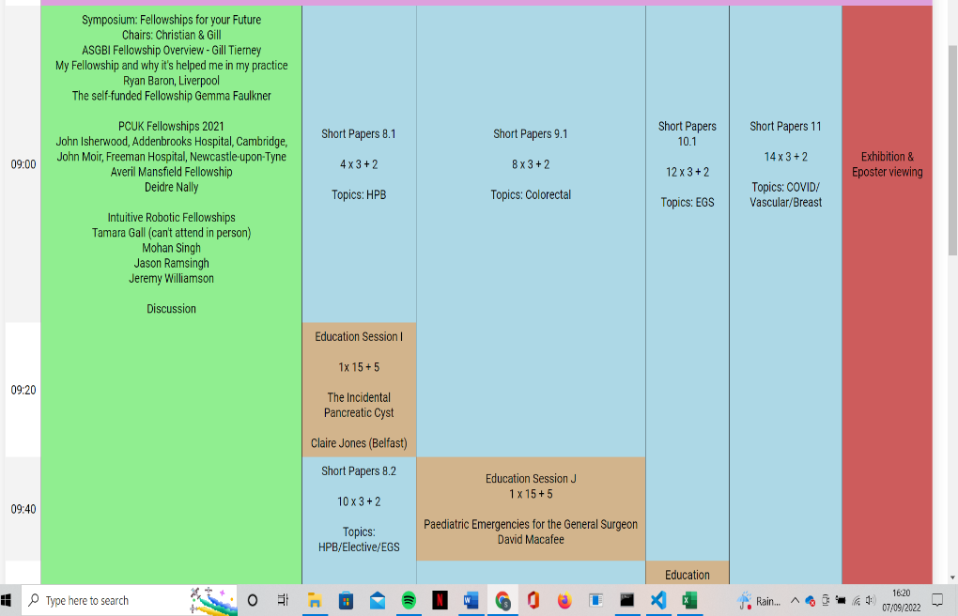

But to indicate that the event finished at 9:20, you could mark E7 as [n]:
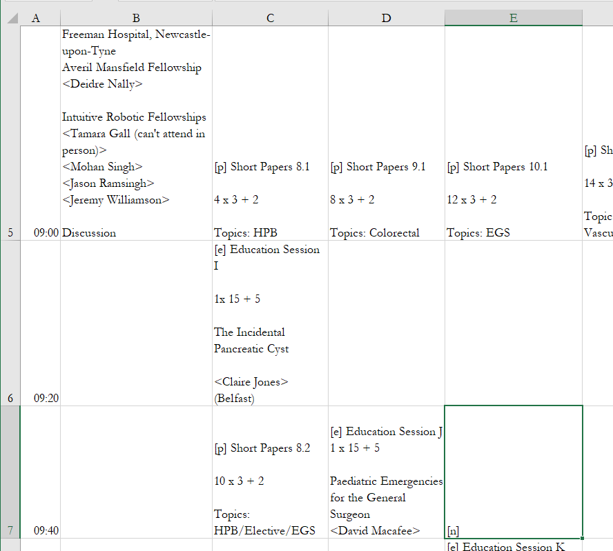
Which would make the web table look like:
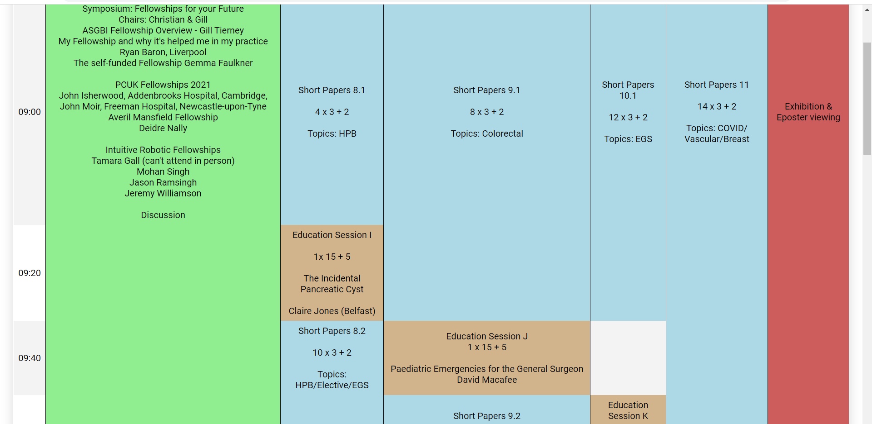

[b] = event for everyone (e.g. registration or lunch break). These go in the B column next to the corresponding time. When the code parses these, it will stretch the event to span across all the rooms
e.g.
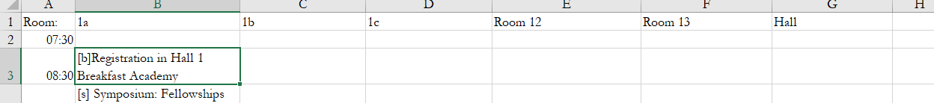

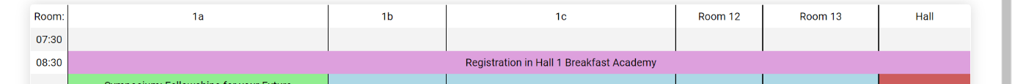
produces:

